Configure Data Synchronization and Virtual Entities between Dynamics 365 Business Central and Power Platform
- Navigate to Assisted Setup and search for Set up connection to Dataverse
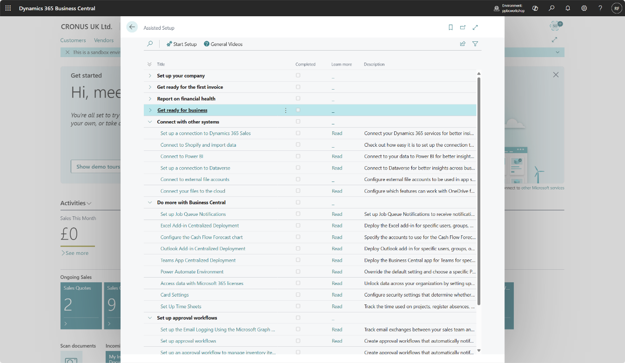
- Select both option to enable data synchronization and virtual tables and events
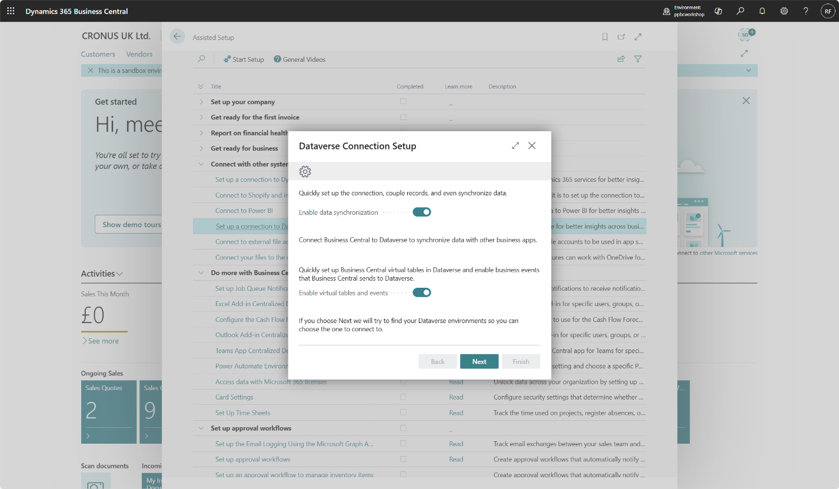
- Accept terms and conditions. Select Next.
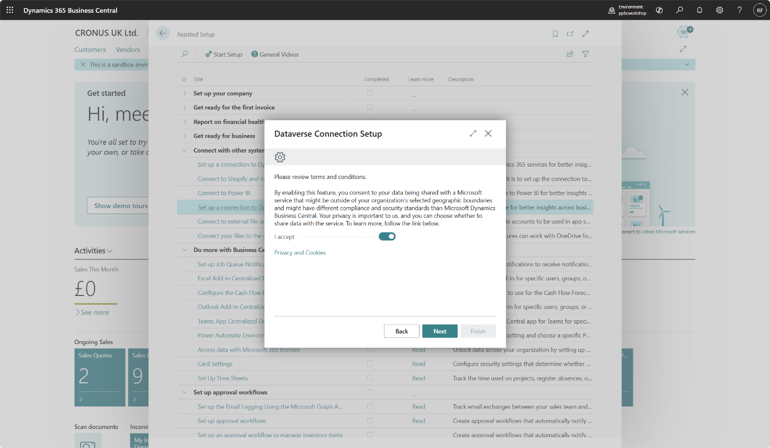
- In case you are asked to allow application to make requests to external service select Allow Always and then select OK.
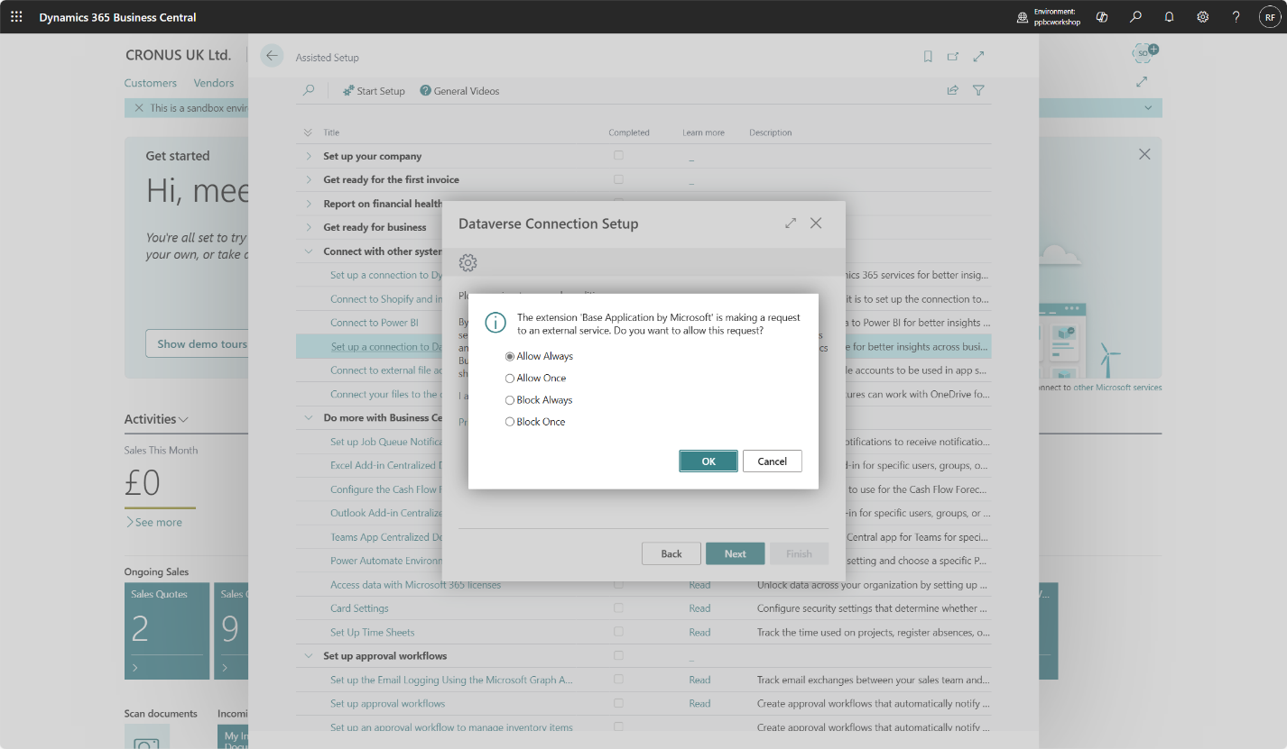
- Sign in with your administrator account and select Power Platform environment created as part of preparation for the workshop.
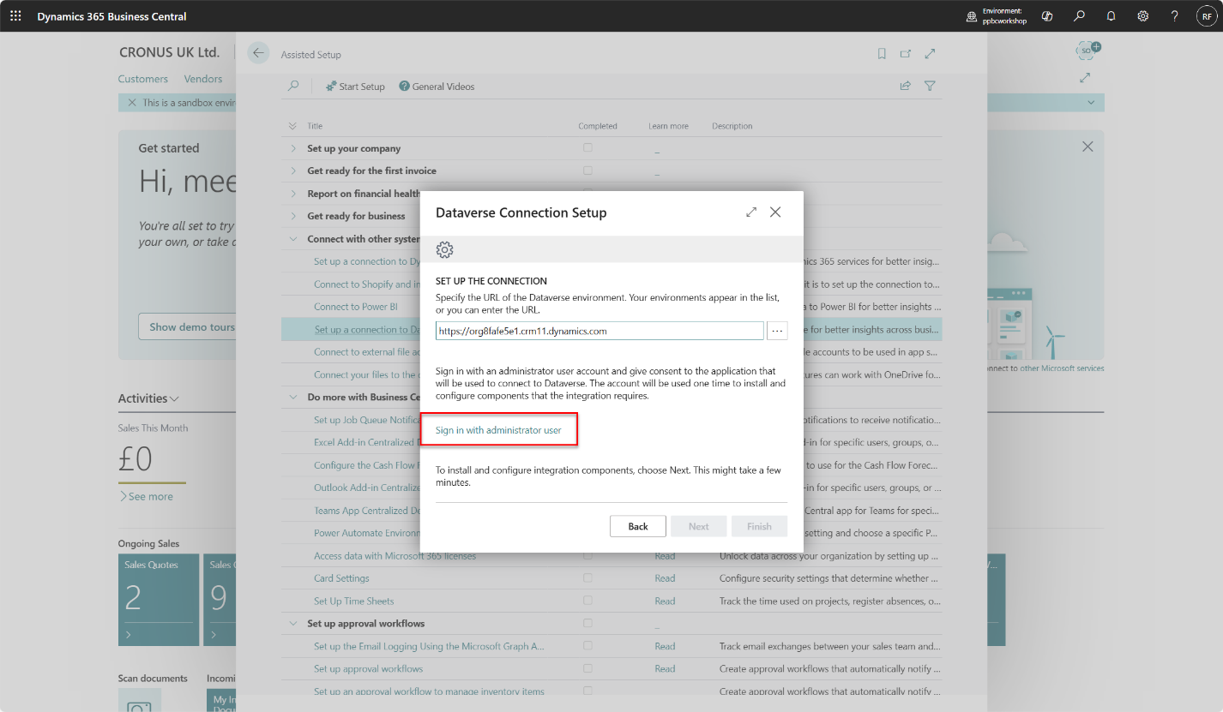
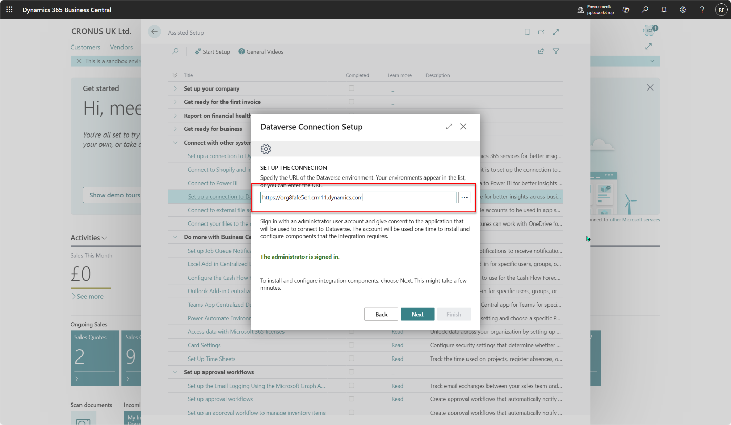
- Choose Team as ownership model and select that you want to complete setup without synchronization. We will do this step later manually.
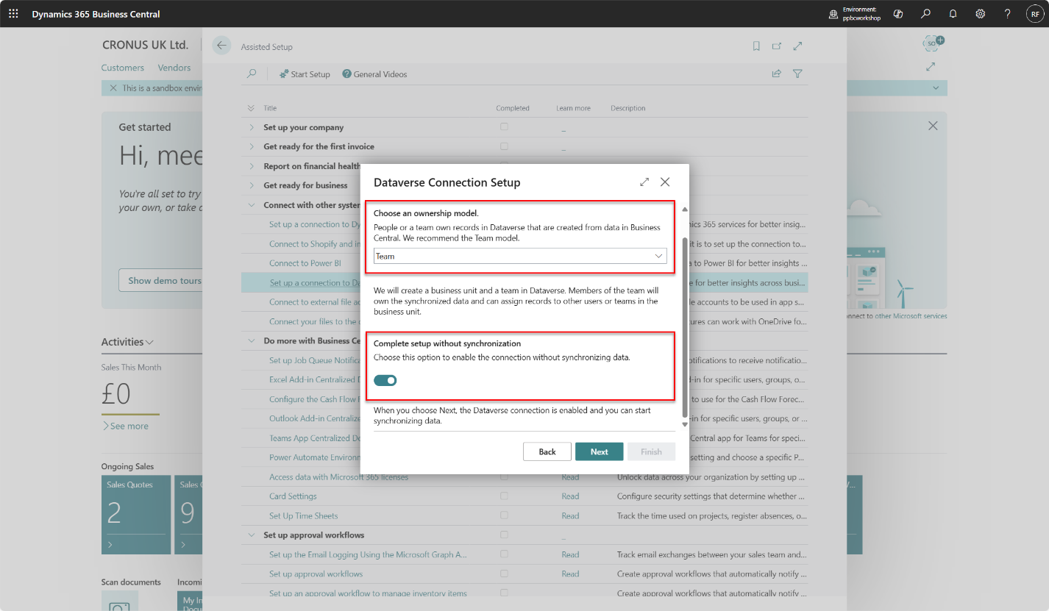
- To enable Virtual tables we need to install Business Central Virtual Table Power Platform application.
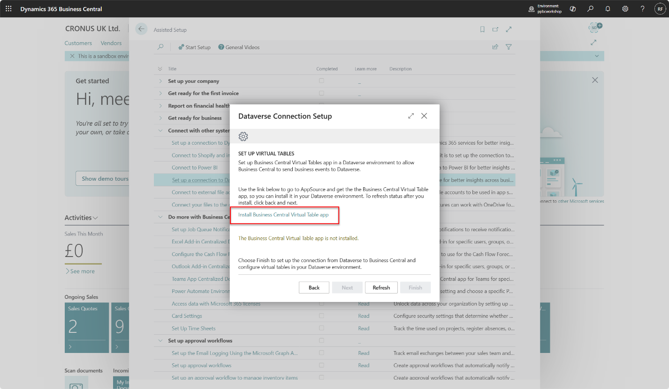
- Select Get it now.
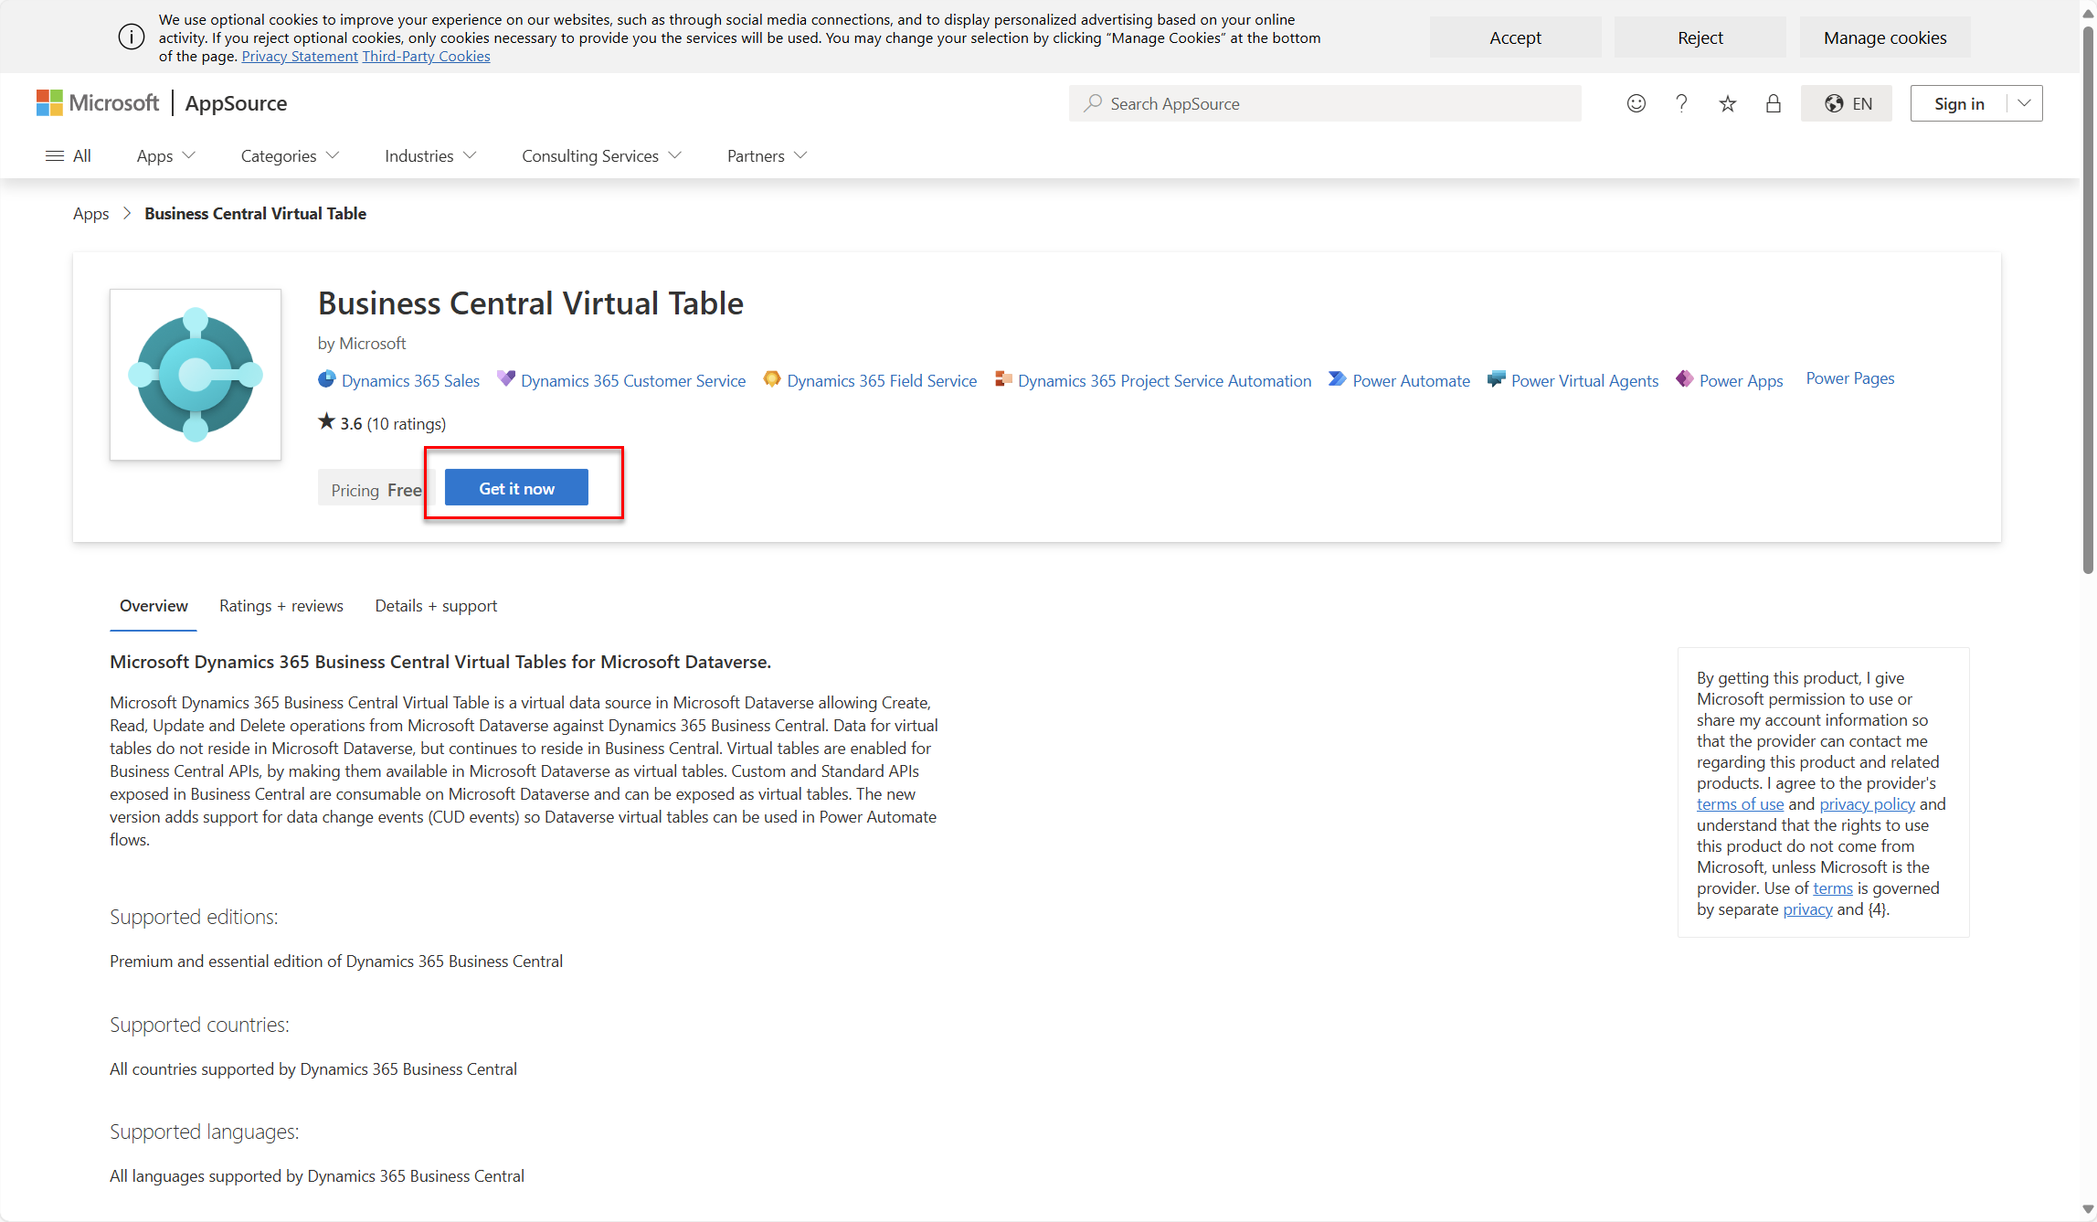
- Enter your administrator e-mail account.
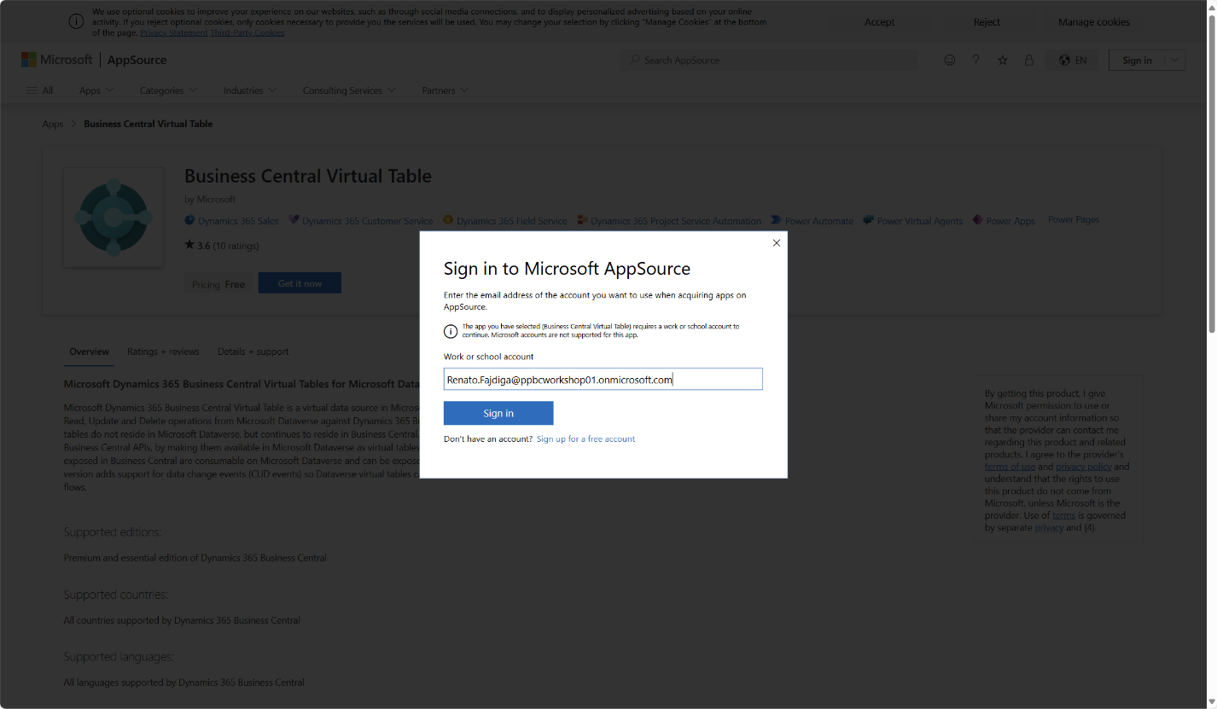
- Select Get it now.
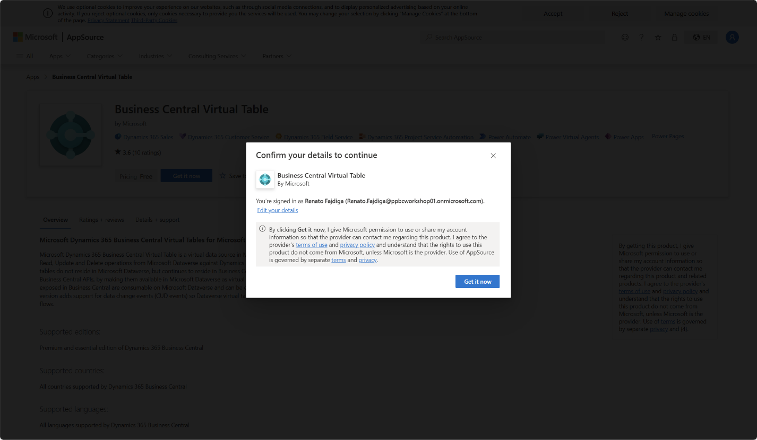
- Select an environment created as part of the preparation for the workshop. Select Install.
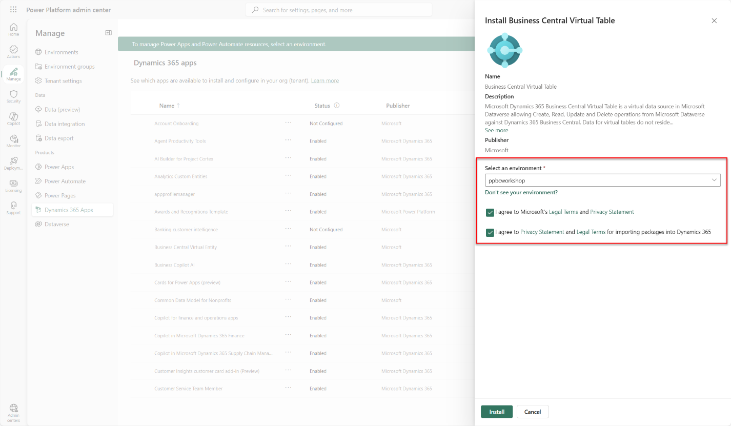
- You will see that Business Central Virtual Entity app is installing.
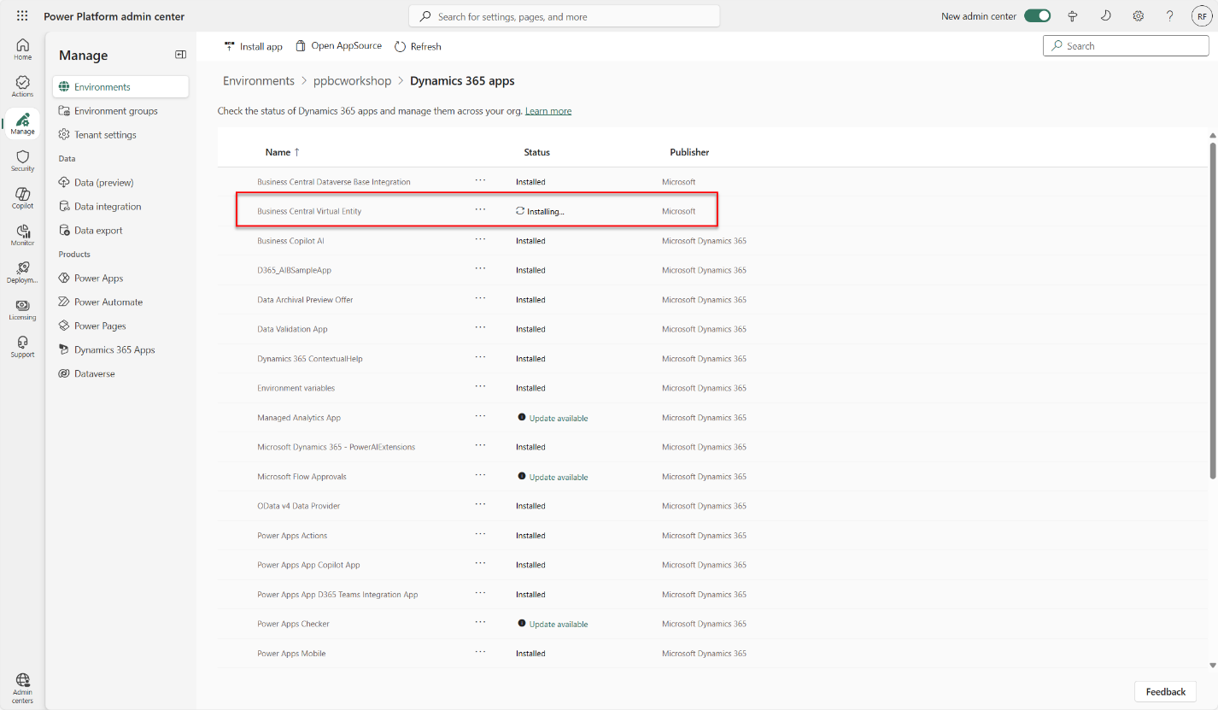
- After a few minutes your Business Central Virtual Entity application will be installed.
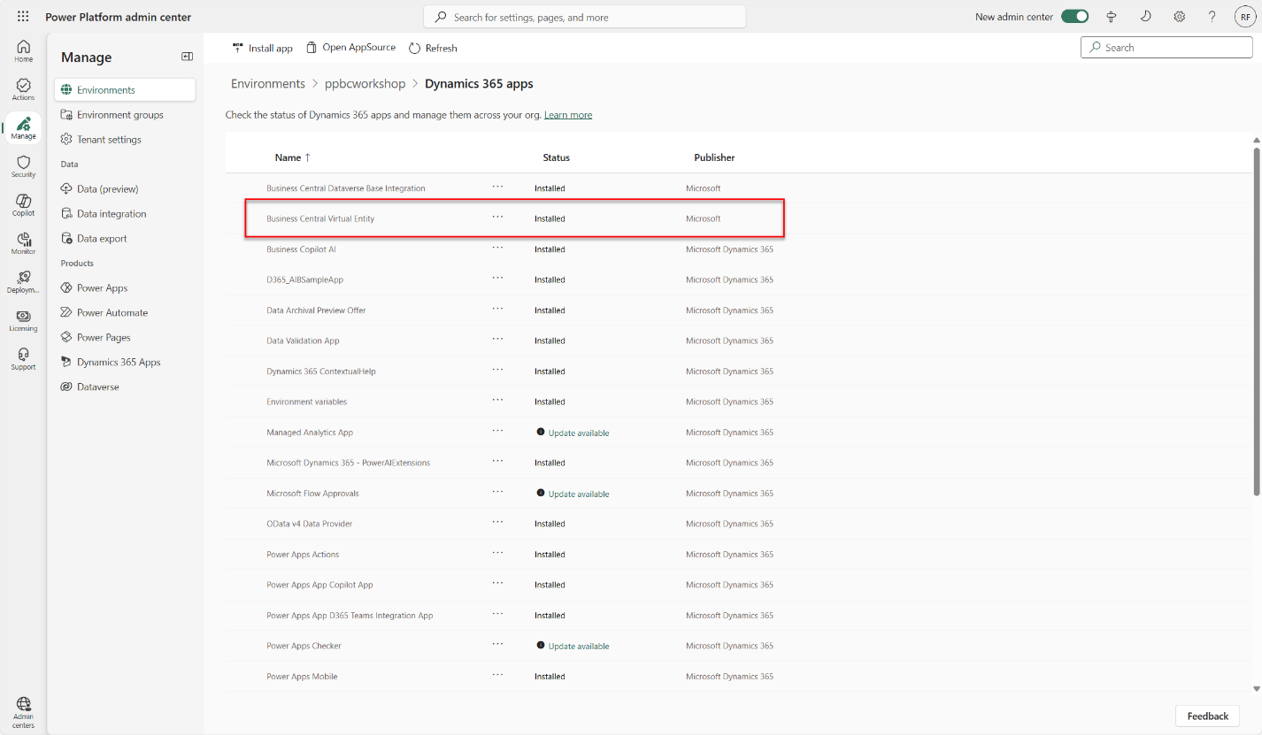
- Return to Dynamics 365 Business Central and select Refresh.
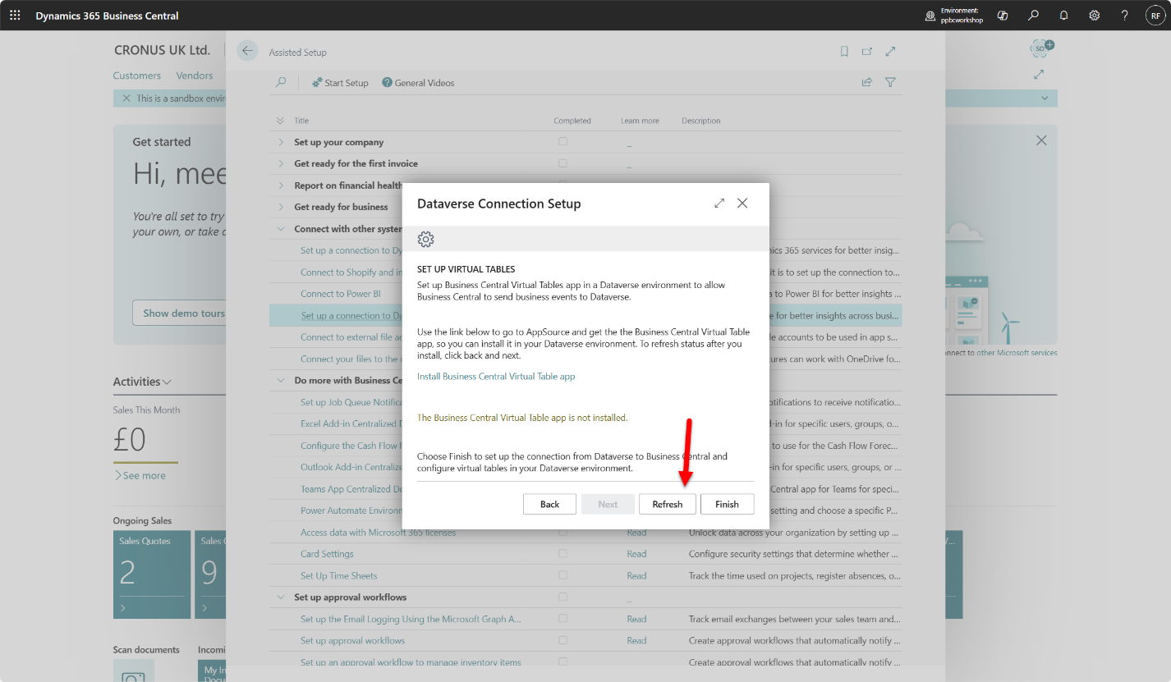
- You will see all green, and message The Business Central Virtual Table app is installed. Select Finish.
